Project Summary

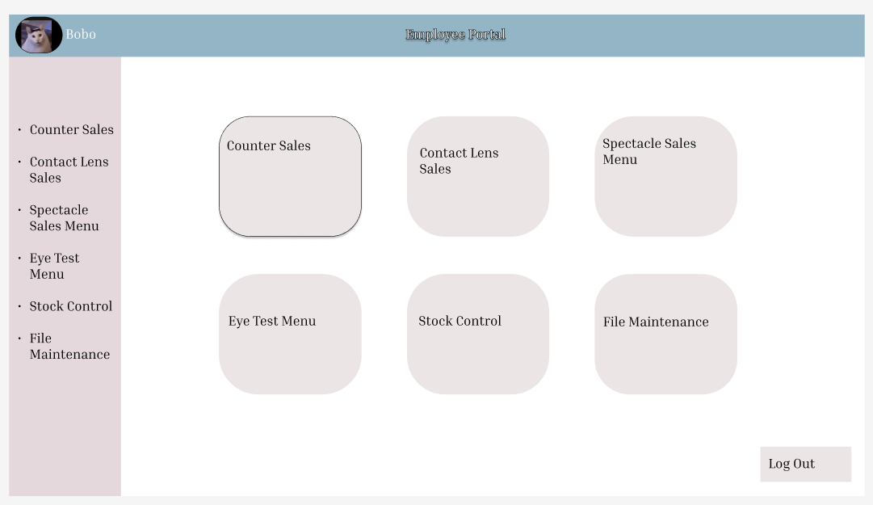

So, behind our thought process we wanted to design and create something that will be robust easy to use and easy to understand. After having identified this component and implemented the into our design we decided that a colour palette would help use achieve this desired effect, as the contrast of complimenting colour palettes would greatly impact how our product looked.

This is the design we came up with for our main menu for the opticians control panel. Placing the user's name and profile picture in the top right corner adds a personal touch. This not only enhances the user experience but also ensures users are aware of their account status, promoting a sense of security. Highlighting "Employee Portal" prominently in the centre of the page provides clear orientation. It serves as a visual anchor, letting users know where they are in the system. The decision to include a navigation bar on the left side is practical for easy and quick access to different sections. This consistent design choice fosters familiarity and efficiency for users navigating the system. This will be a reoccurring component in the website for fast navigation between different section. We wanted to make a minimalistic main menu that leads to other larger sections like file miniatous and stock control. Opting for a minimalist design for the main menu with rounded edges is a great choice. Rounded edges soften the overall appearance, making it visually appealing and reducing eye strain.